Developing Local Audiences in Greek Museums
The case study of Tinos Archaeological Museum

By
Zafeiroula Potiri

Dissertation for the Master of Arts in Museum Studies
University of Leicester
September 2007

Dedicated to my Father, Matthaios Potiris,

whose restless efforts for betterment of the life inspired me to keep looking the bright side. His selflessness and dedication towards his culture and humanity are continuously energizing the life of Tinos.

Acknowledgement

I am very grateful to all my lecturers and professors in the Department of Museum Studies, who supported me to accomplish this task. I found it very appropriate to thank my supervisor, Richard Sandell, who guided me step by step in my studies. I thank him for his patience, continuous suggestions and prompt availability.
I want to thank my parents and my sister, Matthaios, Georgia and Elena, who supported me psychologically, emotionally and financially throughout my studies. Without their support it would be difficult for me to achieve any success in my life.
I thank all my friends who always are there for me, and especially to those, who acknowledged my abilities better than me and provided support whenever I felt blue during my work on this paper.
I feel obliged to convey my thankful feelings to all the people of Tinos particularly my interviewees, whose invaluable contribution enabled me to complete my research. I thank all of them for their time, trust and patience to answer my questions accurately and precisely.

Table of Contents
Acknowledgement i
Chapter 1: Introduction 1
Audience research as marketing tool 2
Planning of study 3
Chapter 2: Literature review 5
Introduction 5
Previous studies 6
Where my study fits in: 14
Chapter 3: Methodology 16
Qualitative v/s quantitative 16
Characteristics of Qualitative Research 17
Steps to organize Qualitative research 17
Designing the research: Interviews 18
Advantages and disadvantages of the two methods 18
My research method and why I chose it 19
About interviewing 20
Case study 21
Case study: Pros and cons. 22
Selection of Museum 22
Situation of Tinos Island 22
Reasons why I chose this museum 23
Non-visitors interviewees 23
What will be the findings: Hypothesis 23
Interview questions 24
Chapter 4: What Non-visitors think? 25
Non-visitors’ expectations inside the Museum 25
Mobility and accessibility: An ‘elderly’ concern of elderly people. 25
Basic and leisure facilities: Toilets, Café, a Shop … and ‘not only’ 26
Displays & Labels’ should ‘speak’ to the visitors 29
Museums’ shift from ‘an authoritarian figure’ to ‘an open arm friend’ 30
People think about money (free entry, family tickets, free passes) 31
Opening hours of museum v/s working hours of the non-visitors 31
Other concerns: Street signs and parking place 32
Impaired people’s (well deserved) desire for audio and visual aid 33
Replica exhibits, explanatory panels, maps, and model ancient city models 33
Museum context: exhibition and events 34
Guides 34
Education and fun for children 34
Educational documentaries for local student, visitors, families 35
Family events, Children’s activities, organized tours, and leisure activities for elderly people 36
Temporary/short term exhibitions 37
Advertising the museum events and exhibitions 39
Local radio/newspapers/ Television, Leaflets and posters (in cafés, ships, villages) 39
Chapter 5: What needs to be done 41
Accessibility and mobility inside the museum 41
Chapter 6: Conclusion 49
Appendix A: Questions for the interviews of non-visitors of Tinos Archaeological Museum. 52
Bibliography 53

Chapter 1: Introduction

During the last two decades, there has been a change in the museum role in the society. The focus of museums has been turned from objects to visitors in recent years. The museums have been turned from storehouses for artefacts into an active learning environment for the visitors. Museums, apart from exhibiting collections, have started taking care of their audience also. As Anne Pennington suggests, “museums aim to make their collections accessible and enjoyable”. Visitors, as recognized in recent years, are considered one of the most important resources of the museums. The new role of the museum is not only to display the objects, so to create better access for visitors, but also to assist them to get as much as they can from their visit to museums. Considering this close relationship between museums and their visitors, it has become increasingly important that museums should be more open, democratic, responsive and professional. Increasingly, expectations of the visitors have been raised and they expect more involved and participatory experience from their visits. As T. Ambrose and C. Paine argue in Museum Basics:
Museums have to engage interest through active involvement with their users and build on this to achieve their objectives. Museum managers should encourage users to explore and discover the museum’s collections and services for themselves. This is in contrast to the traditional approach still prevalent in many museums where expertise resides in the museum alone and users are perceived as passive recipients of what the museum determines should be on offer.

Audience research as marketing tool
Public facilitation and involvement should be carefully considered by museums. Successful museums place their audience higher in their priorities. The key of success for the museum is to understand the public interests and concerns, and design their services to accommodate their needs. These services should attract and engage the public since new role of museum cannot be considered complete without visitors’ involvement. Developing the audience through non-visitor inclusion is one of the key areas. These studies of audience development include all the factors that have been discussed above.
Regardless of their size or location, either smaller or larger or even national, museums of all kinds are looking forward to strengthen their relationship with the existing audiences and to reach new and different groups of visitors. The methods and procedures, which the museum uses in order to enhance its services to meet the needs and requirements of its users, come under museum marketing. Prior to design any museum marketing strategy, it is necessary to complete market/audience research. Market research is considered as a helping tool for museums to identify their audience’s needs. Audience research helps to identify the museum and visitors needs and museum marketing is necessary in order to fulfil these needs. As in all organisations, ‘marketing is the delivery of customer satisfaction at a profit. The twofold goal of marketing is to attract new customers by promising superior value and to keep and grow current customers by delivering satisfaction’. Marketing depends on the combination of certain factors (i.e. product, price, place and promotion) which are known as a ‘marketing mix’. This research would help the museum to understand about visitors’ needs and interests and reasons why they do not visit the museum. This research also provides the information about the existing services of the museums if they meet the needs of the audiences or not. Visitors studies can help the staff of a museum (from curator and educator to the marketing staff) to communicate better with the museum visitors. In this way, any museum can use these studies in order to find out who current visitors are and who potential visitors might be, and what those barriers that stop them to visit are. Market research is necessary, either for a new museum, when it is under development, or for an existing one, and it is helpful to address new market segments and developing new audiences. It enables the museum to measure its success by the number of the visitors and by learning their opinion about museum and their experiences during their visit.

Planning of study
Good planning can help to better control a visitor study. However, there are some important parameters that need to be considered. First of all, for good visitor research an overall aim needs to be set. This will identify what the researcher needs to know and why. Furthermore, the aim must be clear and potentially achievable. Finally, clear objectives should be also set, so the whole study should be well oriented and the findings should be absolutely relevant to the topic.
As Pennington states for good audience research, there should be clear aim about what will the study achieve and how: I have chosen to study about local audience development where the local audience is not involved with the museum.
Because audience research is such a vast area of inquiry, I have chosen to focus my discussion on Greek museums due to their historical reputation and, at present, their poor involvement in the public life. Greece is a country well known in the museum and archaeological world for its rich history and important heritage. It has a large number of museums that store and exhibit this heritage. A large number of foreign visitors visit these museums every year. In contrast, local people don’t visit these museums regularly, if at all. Due to these conditions, I found that there is a great need of marketing and developing procedures in these museums in order to attract the local audiences. As I found during my research, there is very little amount of research that has been done in this area in Greece.
My study, in the context of situation in Greece, will focus on the reasons that hinder the local audience to visit museums. This study will also try analysing the expectations of the local audiences of the Greek museums and will suggest methods to develop certain procedures to meet these expectations.
Due to the nature of my study, I found qualitative research more appropriate than quantitative research. I collected the audience response in interviews and through qualitative research methods, I was able to analyse the data gathered through these interviews and to form the categories from which, I drew my conclusions concerning required marketing and development strategies in local Greek museums.
Chapter 2 of this thesis explores previously completed studies in this area in order to set its conceptual framework. In this chapter, previous surveys in the same study area will be considered. This chapter also provides some examples of other countries’ museums that have similar audience involvement and provide comparisons with other countries that have developed their marketing procedures in their local museums.
Chapter 3 discusses the methodology used in this study in detail and provides the reasons to choose these methods in order to explore research question. In this chapter, I will also try to provide some contrast of different methods in order to explain the exact reasons why I chose this particular method (interviews and case study through qualitative research) to complete my study.

Chapter 2: Literature review

Introduction
Audience research and museum marketing, as discussed in the introductory chapter, has changed in recent decades, with studies focusing more on audiences rather than on keeping collections in museums. In this context, various studies have been conducted and the question of audience involvement has been explored in many different ways. Previous studies indicate that new perceptions were formed after 1940. These new perceptions include the preservation of cultural heritage, protection of this heritage from illicit transfer and providing more access for the general public. During the 1950s and 1960s museums became more democratic in providing access to everyone rather than to a specific group of privileged people.
As we move further in exploring past studies, audience research focuses on studies of local and non-local public, and provides more details on the behaviour and socio-economical factors of the audience in order to develop the answers for the audience research questions. Following this chapter, I will elaborate on certain recent studies that develop the conceptual framework of my study. These Investigations show the flow of audience research studies in last few decades and their findings. Also these studies can be representative of the audience research that is going on in various areas of the world, especially the USA, Canada, and the UK. As my study will focus on the situation in Greek museums, this framework will provide the context and foundation for my study. I will build on previous research methods specific to audience research within museum studies. I have chosen the following papers from a vast number of studies in this area due to their direct relationship with audience development and the understanding of audience responses. These studies are most relevant to my paper because of the methodologies used to approach audience response, and the fact that the research focuses mainly on the needs and wants of the audience.

Previous studies
Dunkan Cameron, in his article ‘Museums and Public Access: the Glenbow Approach’, in 1982, provides a flashback on the museum visitors’ access problem in the past, and uses examples of some of his personal childhood memories. He shows the importance and connectivity of physical and intellectual access to the museums. He claims that all the museum visitors have the right to access all museum resources, and preventing them from doing so could lead to denial. He also mentions that the lack of information about collections leaves them meaningless and they may misunderstand them or, in the worst case, ignore them. Intellectual access means displaying all the available data about the object. Furthermore, he explains that a museum is a resource for all the visitors; it connects them with the collections, with the staff and everything else that it has in it.
At the end, Cameron quotes the criteria/objectives for intellectual access in museums in 1980’s (which is also the chronological period during which he wrote the article). These are: the physical access to the museum facilities, the physical access to the collections, the intellectual access by making information about objects available to the general public, the simplification of information, the accessibility of more resources than merely collections (i.e. research etc.), and providing to interested visitors the information about objects through simple and synoptic presentations. Cameron claim on access (physical and intellectual) to the museum collection and information is one of the main point of my study and my study will focus on this point to understand if audience feel their access to the museum or not.
Cameron discuss access of visitors, Marilyn Hood, in her study “Staying away: why people choose not to visit museums” in 1983, and sets the question, why museums, despite of all efforts to provide facilities, not attract all possible audiences? Why always there are some ‘non-participants’ who decide not to visit the museum? She reviews the research during last half of the century and finds that many studies have been done in order to explore the answers for the above questions. The part of the population visits the museums, apart from highly educated, is salaried young people. She emphasizes the importance of ‘psychographic characteristics’ of both, visitors and non-visitors; how they spend their leisure time, their interests, values etc. In this way it is easy to define the differences between these two groups and to develop plans to attract non-visitors. Hood enumerates some of main choices of people in their leisure time; amongst these choices are: the social interaction and having new experiences. She refers to a survey which was conducted by the Toledo Museum of Art, Toledo, Ohio, in 1980-1981. Questionnaires were given to some invited participants from all backgrounds and it was found, through these questions, who are regular visitors and who are non-visitors and what their reasons are. It was interesting finding that occasional participants are closer to the non-participants than to the frequent visitors. Moreover, family-centred activities are desirable more from the non-visitor or occasional visitors than the regular. Overall, she found that different groups are looking for different benefits in their leisure time.
Hood concludes with the point that museums must find other ways to attract the non-visitors based on the criteria which two groups desire in their leisure time. She suggests that museums should create the link between objects collections and their visitors’ lives. And by this, the current programmes should not be abandoned. As, concerning the occasional visitors, museums should provide the facilities so they could feel comfortable physically as well as psychologically. Finally, the author proposes that the museums should include the occasional and non-visitors by finding their interests and needs and providing them what they find missing in museums. Hood’s findings about the people’s leisure time and their interest provides relative theory to my work here since my interviews also focus on finding the local public’s leisure time habits and trying to find how they can spend their leisure time in the museum.
David Prince’s survey approaching non-visitors is also very relevant study within the same context of finding reasons of non-visitors. In his research about “Factors Influencing Museum Visits”, in 1990, he claims that museums orientate to both: places of exhibition and preservation of the heritage, and to visitors that they will attract. Since the mid 1970s, the museums have grown up to: academic institutions, symbols of local importance and pride, and places of education and entertainment, especially in UK. Based on that, there is a continuous increase of museum visitors. Furthermore, museums nowadays are seen as businesses and they receive financial support by a variety of factors. Amongst them are: the government, local authorities, schools etc. Despite the above mentioned facts, museums sometimes do not seem to support their perception as social institutions. So, there is a general query how museums, though they are social institutions, seem not to pay attention to visitors’ needs. Based on that, a country-wide survey, the first study on visitors and non-visitors perceptions in museums as social institutions in UK in 1988, was undertaken in Lincolnshire. When considering museum survey, museum audience contains from: the visitors, the potential audience and the target audience. Most visitor surveys focus on on-site audiences, their needs, likes, dislikes etc. But there is great need, also, to consider the non-visitors, as potential audience, and their understanding of museums as both social institutions and visiting destinations. This survey report categorized their sample into three classes, i.e. salaried middle class, the intermediate group and the working class and derived conclusions by taking consideration of social and educational backgrounds of the participants. This study found ‘no encouragement for museums to improve or enhance their retailing facilities or potential. Special and temporary exhibition were also not supported significantly in this survey results. However this survey suggested arranging workshops where visitor can see people making and doing things. The study emphasized, in the conclusion, on the need of continuous communication to the public about the museums roles and aspiration. Prince’s findings shows different angles of the audience studies since he focused on non-visitors and found that many ‘facilities’ that attracts visitors may not be much of interest of non-visitors. This also provides my study a different angle to explore if some of the non-visitor in my particular case study falls under the same category (i.e. they don’t want to visit it anyway).
Vanessa Trevelyan, in her article “Non-Visitors with attitude”, in 1991, tries to find out the reasons which force people not to visit the museums. She brings examples of some excuses that people provide when they choose not to visit museums. First of all, they worry that they might not be able to understand the labels because they are written in museums stereotypical language. Moreover they may have some problems of mobility inside the museum, especially if they visit accompanied by their children, or carrying a baby stroller. Also they are not sure if they can have facilities related to babies e.g. changing tables or baby rooms etc. Trevelyan discusses about the survey which was conducted by the London museums Committee and Services about the attitudes of non-visitors, particularly who live closer by. In the detailed discussion published in the report by London Museums Consultative Committee, she analyses the factors that keep people away from the museums, physical and psychological. Some of them are opening hours, mobility of the people with disability or families with children, museum staff’s attitude, language of the labels text, and museum environment for minorities. She describes the qualitative procedures that were followed by discussions with a variety of focus groups, like elderly people, mothers with young children, disabled people and some ethnic minorities of the area. By the interviewees’ responses, the study concludes that although people know about the role museums play but they would not visit them so easily because of a variety of reasons. It could be their bad experience during their school time visit, and now they are not willing to change their opinion and also are unaware of the changes that have been done in the museums. They compare the environment of the museums with churches or the libraries. They think that these places are for families or for the people who are interested in a specific research. Some of the respondents claimed that they prefer to visit big museums than local ones, although the later is cheaper to visit. They find them more antiquated, without interesting activities they can participate in. In conclusion, “museums were perceived as unwelcoming, unattractive and lacking in interesting exhibits”. People find them expensive, with physical barriers which exclude the disabled, elderly people or mothers with young children. Finally, people believe that the performance of the museums lack certain advancements; they (most of the time) don’t use media or other modern techniques to attract the public and as a result, they cannot compete other public attractions.
Trevelyan’s study gives me direction for my study to explore audience responses more critically since they might be using excuses based on their bad experiences in their past or childhood. Her exploration of different groups’ needs may also help my identifying different categories in my audience and their particular needs.
Nottingham City Council carried out a qualitative focus group research in November 1993, in order to find out the views of users and potential users of Nottingham City Museums and Art Gallery about them. Many people were interviewed about a variety of topics. The museum visitors responded that main reasons why they visit the museums is their interest in them and the context of museums, the entertainment that they get out of the visiting museums, and the information/education that museums offer to them and their families.
On the other hand, the non-museum users had different opinion on visiting the museums. They can be divided into three groups: the unimpressed, the unsure and the unaware. The first category finds museum not pleasant and a main reason is because they had negative experiences in their childhood. The second group is not sure if they can visit the museums. People with disabilities or mothers with young children find difficult to access the museums. They are unaware if the museum provides accessibility, mobility and other important facilities to them, or even if they are welcomed. The third category is unaware about the existence of museums and they are not interested in visiting them. From the survey, it was derived a clear conclusion: that non-visitors have reasons for not visiting the museums. First of all, most of the times they have bad impression about museums in their minds. Possibly, based on their childhood visits and they consider them as a strict place that there is no freedom or they would not be welcomed. Secondly, based on their memories, non-visitors find the museums as places for only a specific part of the public, the educated people or the specialists. They found label texts difficult for them to read and understand them, and feel unattached to them since after all these labels are not useful in their lives. Finally, there is an information gap that forces people not to visit museums. People are uninformed about the museums, its facilities, its opening hours, or even the entry fee. There are some other conclusions from the interviews of all the groups; museum staff must be aware of information considering the exhibits, museums must have some interactive activities for all the visitors, like guide tours with headphones, display cases at the convenient height for children and disabled people, availability of audiovisual equipment, provision of kid’s activities etc. Moreover, regular museum users would prefer some things to be changed in the museums, and, both, users and non-users, require specific facilities inside the museum, e.g. comfortable toilets, better shops, facilities for mothers with babies, better information etc. Interviewees gave ideas about how the museums should be advertised. Some of them are: information in local newspapers, radio and TV advertising, posters etc. Also, they stated their opinions about paying entrance to visit the museums. Most of them answered that if there is something worth visiting, they are willing to pay for it but at a reasonable cost.
In conclusion, it was derived from the whole survey that both visitors and non-visitors need interaction to go to the museums, facilities for all the groups, establishing link between past and present through exhibitions, and entertainment offered with information and education. I chose this study useful and within the same context as my study also explore the audience within same categories e.g. ‘unaware’ and ‘unsure’. Although my study focus is mainly on the changes required in the museum and outside of the museum, but these categorization will help me organizing my audience response. The findings of this study also provide good context to the advertisement means as local museums of Greece, most of the time, are not using any advertisement strategy. Above all, psychological experiences, special groups’ needs and focus on the kids and families needs are also common backgrounds for my study.
Joselyn Dodd and Richard Sandell, in their book “Building Bridges”, in 1998, discuss about audience development and, through many examples of museums in UK, provide guidance on that. First of all, they support that the audience development is necessary in every museum. Although it demands a lot of work and time devoted to them, museums should take care, not only of regular visitors, but they should also care why some people choose not to visit them, or, even after visiting them, they decide not to visit them again.
Nowadays, museums show interest in broadening their audiences and try to find out what are that factors stopping non-visitors to visit them. In this way, museums are developing ways of study and they come closer to their audiences. But, some of them, the small ones, need some guidance on that. The authors claim that their work not only covers this need of new audience development, but also it provides ways and strategies about how to achieve it, or ideas about how to strengthen the connection of museum with the existing visitors. With extensive explanation about the meaning of ‘audience development’, Dodd and Sandell are providing the reasons why to put the visitors needs first, and how to avoid the exclusion of the rest from the museum.
They report the reasons why museums should develop new audiences, and, amongst them, they posits: the competition with other museums, the need to justify the funding, the need to increase the income from the museum visitors, the need to prove to the community and local authorities that they are engaged, the pressure for equal access to the museums from political groups. Furthermore, they consider the advantages that every museum gets through audience development. These advantages include: the attraction of more and more visitors, and especially those who would never possibly thought to visit the museum, the ability to show their social status and importance, the increase of the incomes by meeting the criteria set by the funding sources, and the promotion of the idea of equal access to the museum and all its services to the general public.
The writers continue by giving the spark to some museums that may be unsecure by taking the decision of proceeding to audience development. They suggest observing the current visitor figures – the age groups that they belong to, their social background etc. In this way, it is easier to think who might be the potential new audience and how to attract it. Moreover, because the audience development is recent in museums history, museums should take ideas from communities and other non-museum organisations and consult them about the decisions they take. Also, the lack of funding for audience development and less sources is not the factor that stops the development procedure. In fact, this can be resolved with simple steps by observing the museum visitors and finding the missing audiences and providing comforting means that require less or no financial requirements. Finally, the museums should adapt some changes in order to gain more visitors, though they may lose some regular attendants.
Finding out and being aware of the audience needs is something vital an essential in the audience development procedures. This information is invaluable and helps to understand who is currently visiting the museum, what experience they get, and who do not and why. In order to succeed and get this information, the museum must follow some steps. These are the market research, which help to identify the existing and potential visitors, and the evaluation, which actually confirms if the methods which the museum uses are effective, and, if not, what should be done.
For understanding audience’s needs, it is important and extremely valuable to meet and discuss with the target audience. Speaking to the individuals will affect directly the purpose of museum study. Furthermore, by conducting discussion groups with representatives from all the community groups will be provided wider and full opinions and perspectives. Finally, getting involved with the community and talking to individuals will help the museum to understand their point of views which were not clear before. A representative paradigm for all the above mentioned is the survey that have been done by the Elmbridge museum. In order to find out if the museum’s refurbishment will meet the needs of museum visitors and non-visitors, the museum conducted a discussion consulting group. In the panel were individuals from both sides and by all these procedures, the participants felt that they took part in the actual museum decision-making and that they could change the situation the way they wanted.
By identifying the barriers which stop the target audience from visiting the museum, strategies and solutions to overcome them are easier to be found. With another case study of Nottingham Castle Museum and Art Gallery, Dodd and Sandell state successfully their ideas about the link between temporary exhibitions and the attendants. They claim that organising temporary exhibitions do not ensure that the visitors are increased. They may even be disappointed. In order to keep them visiting, the museum must look into their needs and plan effectively programmes for long-term commitment. And great funding is not necessary all the times as the authors explain: “audience development initiatives need not to be costly”.
The writers suggest some audience development strategies and ideas which, if they be used, might attract new visitors. Amongst them: involving the public in making and preparing exhibitions, matching the already existing collections with new ones, allowing on-line and virtual access to the public, planning family-focused activities, ‘spread the word’ plan by creating communication networks, which is low cost marketing also, creating programmes and other activities for foreign visitors, in order to include them through interaction with the museum and its collections, and being in touch with the public, so people will feel close to the museum and always informed about its exhibitions and activities.
I found this study helpful and related to my study in many ways. First of all this research (by Joselyn Dodd and Richard Sandell) provides authentic judgement on the recommendations made by previous studies and suggests that all the changes are not necessarily provides good results if not adapted with good understanding and study of about the needs of visitors. Secondly this study suggests the importance of close interaction of the audience with the museum and its exhibitions through many ways. And last but not least, this study provides simplistic and economical solutions to enhance museum’s audience by offering changes in the environment and interaction with the visitors that cost no financial burden on museum.

Where my study fits in:
Abovementioned studies, focusing on audience development, provide a good base to understand and conceptualize the current study about Greek museums. These researches, mainly held in US, Canada and UK, however miss some exploration of certain socio-economical conditions other countries have. My study will fill this gap for Greek museums. This study will explore the reasons that hold the local public to visit the museums and also will provide discussion on the conditions of the Greek museums that need to be changed in order to involve local audiences. As I found, there is very little amount of literature available about Greek museums, my research will provide the basis for further studies in the same area for Greece. In search of similar conditions, I found missing literature and poor conditions of museums. I also found that there is a very little amount of studies available about the relationship of museum with its local community in several other countries. There were some supplemental works done but not as focused projects. One of the examples of these side projects is ‘Quseir heritage’ project in Egypt. This was the part of ‘The Quseir al-Qadim Project’. In ‘Quseir heritage’, dedicated staff was appointed to involve the local community in the heritage and archaeology of the area. Hence, this work on Greek museums will also serve as pioneer research for all these countries that have similar lack of conditions and literature. This research will provide guidelines about audience development in these countries, not by the examples of already developed museums but by studying real conditions of the local museums in these countries.

Chapter 3: Methodology
As mentioned previously in the introduction, the aim of my study is to develop the local audience in the local Greek museums. The research question points specifically the need of audience research. As Pennington suggests, after setting the aim of my study I chose the appropriate method through which I explore this topic. Although audience research could be done in both ways through quantitative surveys or through qualitative analysis of the data gathered by different means, I chose qualitative for certain specific reasons. Since I intended to find the reasons behind the non-involvement of the local audience, I found it appropriate and more relevant to gather information through interviews and then perform qualitative analysis on the responses of the interviewees. In the following paragraphs I will explain one by one, why I chose a local Greek museum as my case study and why I chose interviewing as my main method to gather audience response.

Qualitative v/s quantitative
Audience research mainly uses surveys to quantify the response of the public in order to find the answer for a particular research. The reason why I didn’t choose quantitative research is because this kind of research is better suited to get demographic data and provides statistical information. This method can answer many general questions as it can help to find out how many visitors come to the museum (visitor attendance), their ethnic background, their origin etc. On the other hand, qualitative research can help you to understand the audience’s thoughts and considerations about the museum itself, its exhibitions and its activities. “Qualitative research can help you begin to understand your audiences rather than simply count them. It is an ethnographic or anthropological approach”. Qualitative research helps to understand the people’s view and opinions. Qualitative method provides more subjective answers as compare to quantitative method even if later ask the same questions. Qualitative study can help in finding ways to improve the experience of the visitors within the museum and it can provide better understanding of the obstacles that the visitors face, both, with physical and intellectual access. This research has a social form that focuses on the way that the people themselves interpret and feel their experiences or the world that they live. According to Immy Holloway, “the basis of qualitative research lies in the interpretive approach to social reality”. Researchers, through it, explore the behaviours, perspectives and experiences of the people they study. Denscombre conceptualizes qualitative research as “an umbrella term that covers a variety of styles of social research, drawing on a variety of disciplines such as sociology, social anthropology and social psychology”. In the light of all above mentioned reasons, I found qualitative method more appropriate for this study in order to get in-depth reasons of audience non-involvement.

Characteristics of Qualitative Research
Holloway mentions about the characteristics of the qualitative research. First of all, the theoretical framework is derived from the data directly, and it is not finite. Moreover, the researchers of qualitative research emphasize the opinions of the individuals who are involved in this research, as well as perceptions and interpretations. Finally, a close connection is developed between the researcher and the researched person, which defines the communication at the interpretation level.

Steps to organize Qualitative research
As Marshall mentioned, every researcher who wants to follow qualitative research faces three main challenges. First of all, he has to be informed about this method and to develop a conceptual framework about his study. Secondly, he has to plan and design the processes that he will follow, so they will be systematic and manageable. Finally, he has to make sure that he will use the findings effectively.

Designing the research: Interviews
While designing the qualitative research, selection of the sample is vitally important since this approach considers the respondents’ opinions more than just counting the participants. Some of the important approaches in qualitative research are the participation, observation and in-depth interviewing. The observation approach is one of the most fundamental and critical methods in all qualitative methods. Observation plays an important role, even in in-depth interviews, as the researcher observes the body language and the gestures of the interviewee. With in-depth interviewing, the researcher becomes ‘instrument’. He enters into the lives of the participants and personalizes the whole procedure. Kahn and Cannel describe this procedure as ‘a conversation with a purpose’. The cooperation between researcher and participant is essential, because interviews demand personal interaction. Last but not least, interviews of any type (informal conversational, general guide approach and standard open-ended) can become a really useful way of collecting big amount of data in short time.

Advantages and disadvantages of the two methods
Both quantitative and qualitative methods have advantages and disadvantages. The quantitative data tend to be more scientific and their analysis seems to be built on objective laws. Moreover, the analysis can be quick and the findings are based on measurements and not on the impressions that the researcher gets. Concerning the cons of this research, we can say that the quality of the data is not so good, considering that computers do this analysis and there is too much complexity. Also, as Denscombre concludes, “quantitative analysis is not as scientifically objective as it might seem on the surface”. On the other hand, the data and the analysis of qualitative research are ‘grounded’ based on theories and, the details and the data have more richness. Furthermore, with qualitative research, the researcher is freer to find and use more than one explanation for the findings. However, qualitative analysis has some disadvantages. The findings might be less representative and their representation seems to depend on the researcher him/herself. In addition, through interviews it is possible for some of the data to be lost or misquoted by the researcher. Finally, some of the findings might demand awareness from the analyst, and if there is not, oversimplification of findings is possible. Considering all of above I found qualitative research more appropriate since it provides more flexibility to find the answers this study is aiming to get. Also since quantitative method cannot find the reasons behind audience behaviour, qualitative is left the only and most appropriate choice for this study.

My research method and why I chose it
For my research, as explained earlier, I decided that the most appropriate way is qualitative research. This helped me to come closer to the people’s ideas and thoughts. Generally, qualitative research helps to understand why and how people act, think and feel. In contrary, through the quantitative research you cannot get the in-depth reasons. It is vital for most of the cultural organisations to know their audiences motivations to visit them. Most of the times, they conduct quantitative demographic researches in order to learn who and how many are attending them. They are less interested to conduct qualitative research on why their audiences attend them and what are the benefits that they are seeking for. However qualitative research methods help to understand about the consumer’s motivation. With qualitative method, we put the emphasis, not on the size of the sample, but on the quality of the questions design and the analysis of the resulting information. These are the case study and the interviews in this research. Survey by interviews is one of the main types of visitor’s surveys and an attractive proposition for every researcher. Visitor survey by interviews offers special contact between the interviewer and the visitor (or non-visitor). Also, this method is appropriate to be used in all the kind of researches: large-scale and small-scale. It helps more detailed questioning and in general, as Clare Conybeare supports, the results of an interview are more reliable than those by other means; and all these can be achieved without the need of complex equipment or the need of extra time to learn new skills. The recipe is old, safe and always successful.

About interviewing
Another main reason to choose the qualitative method is because it requires and supports the in-depth interviewing, which, as I decided, is the best method for the data collection, according to especially for what my study is aimed to explore. Interviewing provides some control to the researcher in order to direct the interview discussion according to the information required for the research and try to avoid unnecessary details if they come along. This technique also help researcher to ask further questions on the spot if she needs more information or explanation for a certain point or she finds new angle during the discussion and wants to add as new question in her study. All these benefits of interviewing are enough to make it main requirement of this study’s methodology.
The in-depth interviews, in qualitative research, have become a very popular strategy in the collection of the data and they provide really ‘rich’ data. With one-to-one interviews and open ended questions we can receive full and explanatory comments from the responders. In-depth interviewing assists asking the people open-ended questions and knowing the reasons without setting presumed questions. Furthermore, with observation through interviewing we can understand someone’s perspective, and we can be able to draw inferences about this perspective that we could not obtain by relying exclusively on interview data. Actually, this is the main advantage of the qualitative research; the research is centred on the interviewee and so some other parameters, like body language, pauses etc., can be assessed.
On the other hand, every researcher should consider some important parameters before using interviews in his research. First of all, she should be definite that she really needs this kind of information that the interviews provide, and secondly, she should be positive that she can be based on this information she will get from the interviewees and she can use them for her own purposes. I chose interviews over questionnaires because my study belongs to identify the visible and hidden behaviours of the non-visitors. Through qualitative analysis of in-depth interviews, my study will be able to discover non-visitors habits, keeping them indifferent to the local museums. In general, interviews are essential part of case studies because most of them are related to human affairs. And these human affairs are important to be reported through the eyes of interviewees in order to provide insights into every situation.
The most common ways of qualitative interviewing are the unstructured interviews (without standard type) and the semi-structured interviews. For my research I found more appropriate and suitable the second one. In this way of interviewing, the people respond with their own words and within the time they need. Also, the researcher makes the questions with the order that she thinks it is more appropriate to each of the interviewees, but in the same time she makes sure that she gets all the necessary information, that she needs to receive about her research topic. In this way the informants feel free to express and report all their thoughts and opinions, and the interviewer is satisfied because she gains all that she wants without forcing them.

Case study
An essential and the biggest part of my research is the case study I chose. For small-scale researches, case study is really famous and widespread. In a case study, the researcher is encouraged to use a variety of methods and sources and to follow other procedures. Besides, one of the most important ways, to get case study’s information, is the use of interviews. A good case study requires the researcher to justify the reasons why she selected the particular case and why this is suitable and necessary for the purposes of the research. The main purpose of using a case study is because it serves as a representative and so the findings can be generalized for the whole class it represents. In case study, researcher performs a crucial task of identifying the significant features on which comparison with other cases can be made.

Case study: Pros and cons.
Every case study approach has some advantages and disadvantages. According to Martyn Denscombre, first advantage can be the holistic analysis that we gain without isolated factors. Also, this approach allows the use of a variety of different research methods. Finally, the researcher needs to concentrate only to one research site or just few. On the other hand, in the disadvantages we can include that the researcher needs to be careful to suspect and demonstrate the extent to which the case is similar to other of its type. Moreover, the case study can be unwarranted. The researcher needs to be careful to details and rigour in the use of the approach.

Selection of Museum
Due to the scope of my study, I intend to choose the museum in the region where all the conditions are met to study i.e. less interest of local public, and a museum with historical background. Hence I chose the local museum in the island of Greece, Tinos. This museum is an archaeological museum, founded in 1960. Its main collection consists on the antiquities of the Tinos Island. This museum has a reasonable number of visitors mainly from tourists. Another type of visitors is schools as part of their extra-curriculum activities. The missing audience, as museum visitor books shows, is local public.
Abovementioned conditions of a local museum are not particular to this museum only, but this scenario could be found in most of the museums in Greece. This is the reason I consider this museum as an icon for this type of studies and chose as representative of all the museums of Greece who have their local audience missing.

Situation of Tinos Island
Tinos is a medium sized island with, as all the rest Greece, many archaeological sites. It contains a reasonable number of people in the city and in its countryside. The city has all the activities of social life and takes active part in the Greece socio-cultural lifestyle. In this context, the museum has very less number of local people visiting that provides the background to the research about the reasons, why local people of the island do not intend to visit the museum, in the context of audience development studies.

Reasons why I chose this museum
The main reason to choose this museum is its popularity among the foreign tourists due to its significance of having historical and archaeological collections. I chose this because this museum fulfils all the conditions to be called a national level museum that is also popular among international visitors. Its location is also ideal for my study, since it is located in the heart of the city and easily accessible to all the population of the city and around. Despite of all these positive points about the museum, the fact remains that the museum does not have mentionable number of visitors from the local population. This missing factor of local people involvement in the museum made it the right choice for this study.

Non-visitors interviewees
As I mentioned above, I chose to interview the non-visitors in order to understand the reasons of them not feeling attached to the museum and not visiting it occasionally. I selected my sample interviewees from the population of the island of Tinos. This sample of interviewees represents of all the people of Tinos since it covers most of the demographic differences of the local community of the island. This group consist of people from all ages, gender, educational backgrounds, and professions. This diversity of the group makes it more appropriate to represent the local community of the island. During the recruitment of the interviewee, the efforts were made to select the people who had not visited the museum recently, in couple of years, in order to get the response of ‘non-visitors’.

What will be the findings: Hypothesis
Through the in-depth interviews, this study will find the reasons local non-visitors provide for not going to the museums so often or not visiting museum at all. The interviews are supposed to provide the answers from all different kinds of people not visiting local museum. Through these interviews, it would be derived that what are the obstacles that stop people visiting museums and what are the conditions within the museum that should be changed in order to attract the non-visitors.

Interview questions
After the basic questions about the interviewee age, gender and education, further questions are made to find the main reasons for a person not to visit the museum at his/her door steps and has popularity among the international tourists. These questions (Appendix A) covers the initial queries about the reasons and suggestions non-visitors have. Further categories would be derived from the responses of the interviewees in order to understand the complete list of categories covering the reasons of non-visitors.

Chapter 4: What Non-visitors think?
Analysis of interviewees’ responses leads the study to explore all aspects that affect the audience visit to the museum. In case of Tinos Archaeological museum, as my case study, I found responses of interviewees covering both problems related to all museums and problems particular to the local museums in Greece. The following discussion explores these reasons one by one in order to compare and find the relationships with previous studies held in the USA, UK and Canada.

Non-visitors’ expectations inside the Museum
As ‘changes inside the museum’ drew attention of many of the interviewees, and they found them more problematic to visit, I discuss this part first, here. The changes inside the museums are covering most of the responses related to facilities, mobility and other factors of convenience for the visitors within the museum.

Mobility and accessibility: An ‘elderly’ concern of elderly people.
Many responses pointed out the difficulty of access and mobility, getting to and within the museum (figs. 1, 2, 3), an issue also mentioned by Vanessa Trevelyan in her study, and Nottingham City museums and Art gallery survey. Almost all the interviewees were either unhappy or unaware of the facilities provided within the museum. These non-visitors felt that they would be more interested in visiting the museum if certain facilities were provided.
“I will not visit it since I am not able to do so. My son told me that there are no facilities for old people there. He told me that there is no toilet for public and especially for disabled ones, like me. He also informed me that there is no place to sit or to take some refreshments and no one can guide you there.”
(Telemachos, 75, retired farmer)
The mobility problem was not only mentioned by elderly people but also mothers with the children and people with other disabilities. This shows that poor mobility facilities genuinely discourage a number of different types of visitors, and that efforts should be made to provide proper mobility for them.
“I would suggest reconstruction of the museum surroundings. The museum must support the access and the mobility inside.”
(Vassilis, 43, Farmer)
“The museum entrance and some inside areas must be reconstructed or repaired in order to be accessible to the people with disabilities or the elderly people.”
(John, 24, postgraduate)

Basic and leisure facilities: Toilets, Café, a Shop … and ‘not only’
One of the reasons that make Archaeological Museum of Tinos is suitable for this type of study is the poor facilities inside the museum building. Many responses support this point, since museum building does not have its public toilet. Non-visitors’ responses indicated many facilities as “good to have”, but they insisted on basic facilities that should be provided in all museums (Hood’s, Trevelyan’s and Nottingham’s researches actually consider the importance of facilities inside the museums).
“I think there should be more facilities provided by the museum, e.g. toilets, baby changing room … and some place to sit and have refreshments.”
(Anna, 39, housewife)
“I would not recommend this museum to other people, because there is a lack of many facilities”.
(Katerina, 39, undergraduate)
“It is not renovated so many years. Latest facilities are missing like electronic screens, digital image displays etc. as well as some basic facilities like toilets, café, museum shop etc.”
(John, 24, Postgraduate)
This response raises the issue of government funding to provide for the basic needs of the visitors that are currently lacking in the museum. Other facilities people mentioned, according to their understanding and needs, include a café, museum shop, children’s area, community or social event hall etc. Some people do not feel it necessary to have children’s area, but mothers insist on it. They feel that this would make the museum experience more enjoyable for both themselves and their children, as it would provide an area for the children to play and allow them to enjoy the museum by themselves, and that it would also encourage the children to want to visit. (Trevelyan in her report mentions that this is one of the main reasons that stop people from visiting the museums).
“That is not proper place to stay for a while as I have young children (8 and 2 years old) and I need, at least, toilet for them if I want to stay for few hours. Also, as far as I know, there is no playroom or a place to relax and take rest.”
(Anna, 39, housewife)
A children’s area is good attraction for the people who spend most of their leisure time with their children.
“I spend time with my children”.
(Anna, 39, housewife)
“I take care of my grandchildren”.
(Sophia, 60, retired teacher)
A Café was suggested by many interviewees for many reasons; some found it as part of culture, for others it is a place to take a break, for the elderly it’s a place to sit and rest.
“I would visit the museum more often if there was a café at least.”
(Helen, 29, lawyer)
“My son informed me that there is no place to sit or drink something.”
(Telemachos, 75, retired farmer)
“I would not visit the museum again because it is the same all these years and it cannot compete other entertainment attractions like going to Café, go for swimming etc.”
(Panayiota, 25, Historian of Art)
Museum shops, although considered normal in UK museums (Nottingham research shown that the audience of UK have the need of better and more advanced shops in the museums), are not common in local museums in Greece, but responses show that people are aware of this missing facility in the museum, since museum shops play a great role in the interaction with audience. People who visit bigger museums mentioned repeatedly that every museum should have shop where museum could sell objects, replicas, models etc.
“A nice change in the museum could be a shop with gifts, especially replicas of most popular exhibits.”
(Loucia, 40, employee)
Some interviewees brought up the idea of providing community hall for social events or educational seminars in order to involve local people into the museum activities and make them feel connected with the day to day life of museum.
“In order the museum to be more attractive to general public, it should be more educational. There should be some exhibitions in combination with recent history of the island, and the museum should provide documentaries about Tinos, or even lectures could be done in museum’s environment.”
(Panayiota, 25, Historian of Art)
“[…] a modern guide book in simple language, so the people can easily understand them… also some seminars about the exhibits and the history of the island.”
(Nikos, 37, Librarian)

Displays & Labels’ should ‘speak’ to the visitors
Some of the interviewees mentioned the poor display settings. Uninteresting labels (figs. 5, 8, 9), badly-lit galleries with poorly displayed collections (figs. 6, 9), and a lack of guidance from staff have a lasting impact on their memories. ‘Object-interpretation’ is a process of making an object recognizable and understandable to the viewer by establishing the links between former and later. Poor lighting, location, length and language of text are the factors that can make the visitor not to read the museum texts. Label text is considered the ‘language’ that a museum speaks to the visitors. If this language is not understandable to the ‘visitor’, they naturally have the negative feelings about the ‘host’. This was the case with the people who suffered with the missing or poorly drafted texts of the labels in the museum (fig. 8). Some of them mentioned that they have lost the interest in all the museums after the last visit since they felt like a stranger to the language used in the labels. Duncan Cameron in his article (but also Trevelyan and Nottingham City Museums found from their surveys) claims that poor information or a complete lack of it in exhibitions may lead to the visitor’s denial or misunderstanding. This missing connection with the labels’ text leads them to feel disconnected with the objects too.
“Actually, I did not like the way the exhibitions are designed; the label texts are poor, the language is scientific and I cannot understand it. Moreover, the position of the objects is not correct and some, although interesting, can skip your eyes.”
(Christoforos, 28, doctor)
“When I am thinking of museums, I imagine an authoritarian place with sculptures, cases, antiquities and labels that don’t help you to understand what you see. This place is only for well educated people or those who are interested about the exhibits. I understand that it is a good place to visit because it holds a big part of our culture but it is not the place where you go in order to have fun...”
(George, 47, undergraduate)

Museums’ shift from ‘an authoritarian figure’ to ‘an open arm friend’
Museum staff, with lack of training on the changing role of the museum, is not considered friendly or welcoming by the respondents. Most of the interviewees mentioned the unwelcoming feeling they experienced when they visited museum a long time ago. Some of them also felt worse and mentioned the unwelcoming way information about the collection and the museum building itself was provided. As previous studies consider the psychological behaviour important in the involvement of non-visitor (e.g. Nottingham research), this feeling of interviewees pointed out the same issue when some sensitive visitors found themselves unwelcome by the museum and its staff.
“I would prefer the museum’s environment not to be so strict, so I can visit it with my young grandchildren.”
(Sophia, 60, retired teacher)
“Museum staff should be more welcome”.
(Antonis, 39, undergraduate)

People think about money (free entry, family tickets, free passes)
Some initiatives in order to revitalize the museum role in local life are required. People will be more interested if there were special entry fees on some special occasions. Museum should hold these occasions from time to time to try and reach out to non-visitors. Interviewees (like those interviewed for Nottingham research) suggested it as basic attraction for them if they find entry free or at a nominal cost. Some were interested in the idea of family tickets, where they could bring the whole family and pay only a fixed fee for all. In the changing theories about marketing it has become vital to provide customers more facilities with least possible cost. Answers of the interviewees support this as all of them asked for concession, either partially or fully, in the entry fee.
“I think that good advertisement for the museum could be free entrance, because people think about it”.
(Joseph, 31, businessman)
“They should distribute free museum ticket to people like me”.
(Telemachos, 75, retired farmer)

Opening hours of museum v/s working hours of the non-visitors
Opening hours of the museums, as mentioned in previous studies as well (Trevelyan), are considered to be one of the main problems that hinder people visiting museums. Most of the time opening hours of the museum are same as working hours of the majority of the businesses in the town. Interviewees, in the context of local museums, found it difficult to spare their working time and go to visit museum. This scenario clarifies to a certain degree the absence of the local public in the museum. Tourists and other visitors from outside could visit anytime of the day but the local public is very likely to be at work during the day time. Responses to this issue suggested that there should be some special opening hour timings, at least for couple of days a week, for the people who cannot visit museum during the regular opening hours of the museum.
“I am working and when I have free time the museum is closed.”
(Maria, 47, trader)
“I have not visited it during last few years because of the fact that it is open only in working hours and, since I am working, I am not able to visit it.”
(Christoforos, 28, doctor)
“If it was open in the afternoon, at least few days of the week, I could visit it, now I am not, since I am working.”
(Joanna, 53, Mathematician)

Other concerns: Street signs and parking place
Although local museums are supposed to be a well-known place for local public, the interview sessions brought up concerns about the direction maps to the museum. Some mentioned the need for signboards in the streets that lead to the museum. their argument about this point was related to providing information and sense of existence of the museum as some people humorously said ‘is there any museum around?‘.
“There should be signs in the streets to orientate the people and the drivers.”
(Katerina, 39, undergraduate)
A small number of people were concerned about parking. They wanted to be able to park their cars without worrying about it and concentrate in the museum. The issue was not raised by many others, but I felt it important to discuss as a visitor’s divided concentration makes him/her less involved in the museum and can make the visiting experience tense.
“This museum could attract me if there was a parking outside or close to the museum.”
(Joseph, 31, businessman)
“I don’t find place to park my car and usually I visit other modern museums.”
(Frangisca, 31, Nursery school teacher)

Impaired people’s (well deserved) desire for audio and visual aid
As found in early studies, people with impaired abilities should also be included in the experience of museum and they should get all the possible help the museum is capable of providing. It is difficult for the local museum to change the whole environment in short amount of time but there are certain things museum could provide with less significant efforts and cost. Audio aids for people with hearing impairment or the elderly is one of these facilities. Responses indirectly asked for aids for their disabilities. Elderly people asked for help in mobility (fig. 3), toilet facility and rest place and they complained about their less involvement with the labels and with the information about the objects. An Audio/visual aided facility could substitute some of these complains by providing them with recorded information, directions and general instruction which they might miss due to their poor eye sight or a hearing impairment.

Replica exhibits, explanatory panels, maps, and model ancient city models
Other than the labels’ text, there are many other ways of providing information to the audience. Some objects can be placed with the models of their related sites or ancient cities. Similar interpretation of the objects can be achieved by putting maps and explanatory panels. For visually impaired visitors, replica objects exhibition could be arranged so they can experience the objects by touch. Responses of the interviewees asked for models and explanatory panels in one or other way. Their main requirement was better and interesting information for all. As discussed indirectly, participant of interviews agreed that they can recommend to other people with disabilities if they find that the museum have such kind of facilities or exhibitions that are specially designed for the people with certain hearing or visual impairment.
“(there should be) maps and panels inside the museum with plenty of information and for all the people, from children to researchers.”
(Beatrice, 23, employee)

Museum context: exhibition and events

Guides
As the under-discussion museum has few members in staff, respondents also complained about the lack of attention they received in the museum. This point combines with the text of the labels and information about the collections; when visitors cannot find someone to help or guide them, they feel helpless.
“[…] no one can guide you there or provide you information about the exhibits, so, there is no chance, for me, to visit it.”
(Telemachos, 75, retired farmer)

Education and fun for children
The requirement of guidance was asked for the children too, since they are more curious and more enthusiastic to know about the objects. Guide staff aiding children’s learning was considered necessary in many responses. The interviewees showed great interest to questions concerning educational activities for the children and adults.
“The museum should be repainted in a new colour combination, more attractive than just a classic look. Also, it should adapt new technologies and put some virtual tours on big display screens. It also can have video games for the children!”
(Nikos, 17, student)
“It would be a good idea if there were guides inside the museum so they can teach the children and adults about the history of the museum and the objects.”
(Anna, 39, housewife)
“[…] Educational activities for children and adults for example how different vases were made or painted etc.”
(Sophia, 60, retired teacher)
“Educational programmes for me and my children, and better information about the exhibits and the antiquities of the island.”
(Katerina, 39, undergraduate)
“There should be educational programmes and activity packs for children to play and learn.”
(Fragiska, 31, nursery school teacher)

Educational documentaries for local student, visitors, families
Educational documentaries for the visitors, schools and families can be considered a good attraction for the non-visitors. Most of the visitors find themselves out of context because of a lack of interaction from the museum text and museum staff. Documentaries can provide better interaction and entertainment with the help of new means of technology usage in museums. Non-visitors responses also support this point by mentioning such kind of activities required in the museum. The Museum’s goal as an educator is identified by many respondents and they insist on having such activities frequently.

Family events, Children’s activities, organized tours, and leisure activities for elderly people
Museums, as discussed while exploring previous audience research, are considered a place that provides education, entertainment and cultural awareness to the visitors. The goal of education through entertainment could be achieved by providing activities for the visitors based on their age, educational and social backgrounds. As interviewees discussed on this issue, there could be events especially designed for families and children. Family-focused activities were a high priority of interviewees in other studies (Dodd and Sandell, Hood, Trevelyan, Nottingham research). Organized tours of school and other community groups can be arranged by the museum in order to introduce them to the changes in the museum and feel more connected with the museum environment.
“I would happily visit the museum if there were some days dedicated to families. Special family trips and activities for children would be a good idea.”
(Anna, 39, housewife)
“[...] leisure activities for families and elderly, understandable label texts for all the visitors”
(Christoforos, 28, doctor)
For elderly people, and people with disabilities, there should be more than just visiting the museum. Some elderly people suggested providing ‘pick and drop’ service by the museum. Some leisure activities, as mentioned by interviewees, can be generated in the museum with minimum changes required. These activities include resting places, and the opportunity to meet with other elderly people and share their memories on certain cultural aspects or historical events.

Temporary/short term exhibitions
The static look of the museum is a factor that limits repeat visits by visitors (figs. 6, 9). In order to attract the visitors to the museum again, it is necessary to keep changing the display settings inside the museum. Another change that is also mentioned by interviewees is to rearrange the existing exhibitions, new objects on display and new temporary exhibitions. These exhibitions serve many goals for museum. These exhibitions attract both non-visitors and visitors, and also promote museum messages within certain contexts. These exhibitions also develop people’s understanding about the museum’s new role as place of education and entertainment.
“The fact is that there is no advertisement to catch my attention. The museum’s exhibits are the same so many years and it is not even renovated for so many years. I think they should borrow different things from other museums to bring the change in exhibitions.”
(Hector, 61, retired sailor)
“I would visit it again if I know that there are new exhibits.”
(Nikos, 37, Librarian)
“It is the same many years”
(Loucia, 40, employee)
“New exhibits and new loans (collections borrowed from other museums)”.
(Vassilis, 43, farmer)
“This museum could easily attract me if there were more contemporary exhibitions about, but not limited to, local history.”
(Christoforos, 28, doctor)
“I would visit it again maybe in the future if there is a new exhibition about my island”
(Antonis, 39, undergraduate)
“I would visit it again because of my job. But I would be more eager if something was changed.”
(Panayiota, 25, Historian of Art)
“I would visit this museum again only with friends. There is no reason to go alone. I know that nothing is changed.”
(Helen, 29, lawyer)
Different types of exhibitions are also considered attractive for the local public. One of the popular ideas is to exhibit objects from the museum collections and display them along with the counter object from recent or modern tradition so the visitor can connect their present with the recent past and their historical identity through learning about the evolution of their very own living tradition. Hood, based on her survey, suggests that museums should create the link between objects collections and their visitors’ lives.
“A nice idea could be the opening of a Folklore Museum inside or next to the Archaeological, so visitors can see the evolution and feel connection to the antiquities.”
(Hector, 61, retired sailor)
“A main reason why not visiting it again is because, as far as I know, the museum is the same all these years. There is nothing new and the information provided is poor and not enough. Also, I don’t feel close to this museum; I don’t feel that it belongs to me.”
(George, 47, undergraduate)
“First of all, I already know about it. Is there any reason to visit it again? Secondly there is no advertisement of museum activities. Finally, there is no connection between the museum environment with the life as it is now and with the Tinos people.”
(Katerina, 39, undergraduate)

Advertising the museum events and exhibitions
Museums, before marketing theories became popular in museum studies, were considered places only visited by selected groups among the community. Since, as this study has gone through, museum role has been changed over the period of time and it has become unavoidable to overlook the marketing of the museum at local and national level. Advertising is the key of marketing a museum. If a museum is not advertised, it does not exist in people’s mind.
“I don’t hear anything about this museum. It’s like it does not exist!”
(Maria, 47, trader)

Local radio/newspapers/ Television, Leaflets and posters (in cafés, ships, villages)
There are different suggestions or expectations about museum advertisement. Some people expect it through traditional ways like pamphlets, posters or boards, while other people find new means of advertisement like radio and TV more approachable to the people. The interviewees of the Nottingham research gave the same responses, by which we can understand that the people’s thoughts and needs are similar all over the world.
“After I visited last time, I haven’t heard about it. I think it should be advertised through local channels and newspapers. It would be nice if there was a new exhibition about Tinos citizens. A good advertisement could be posters in local café.”
(Panayiota, 25, Historian of Art)
“I rarely hear about it. It should be advertised in local newspapers, magazines. And local authorities should advertise it.”
(Fragiska, 31, nursery school teacher)
“I don’t hear about the Archaeological Museum. Good way of advertising could be in the touristic guides, with posters in ships, and maybe a Museum Friends Society to provide information about the local museums to local people.”
(Hector, 61, retired sailor)
As new media have become part of life, especially with the youth, some responses from the young people point out the need to advertise via the internet or mobile messaging. But this point was not supported by other responses from the local people, as Tinos is not exposed to all advancements in the technology about media and advertisement, especially to elderly people and people living in the villages around.
“I use to hear about this museum only from friends who visit it with school. I think they should put signs on the local buses or they could use SMS advertisements these days.”
(Nikos, 17, student)
“There should be advertisement everywhere, especially in the villages.”
(Joanna, 53, mathematician)

Chapter 5: What needs to be done

The purpose of studies like this is to listen to people (either visitors or non-visitors) and try to find the reasons of their non-involvement in the museum and put the efforts to remove these reasons. As we have found a number of reasons behind the non-visitors attitude of not visiting local museum in Tinos, are very appropriate to highlight those conditions that are first to be addressed in order to involve these non-visitors. In the previous studies, as I mentioned in the literature review, I found some similarities with my case study where these studies discuss about the changes required inside or outside the museum. For example Trevelyan’s report discusses about the opening hours, mobility inside the museum, label’s text language and about the staff’s attitude towards the visitors. On the other hand, I found some of the studies discuss and analyze audience development issue at advance level, and I found them less relevant to my selected audiences’ response. The reason behind this is the situation of the museums in Greece, which are missing some basic facilities. Prince’s study, for example, found café, shop or other facilities less attractive to new audience, but in my case, these missing facilities can bring vital change in the non-visitors behaviour. Hence, following recommendations would limit the audience response of my case study and provide a direction to develop local audience for the local museums in Greece in particular and local museums with the similar conditions in other countries, like Egypt.

Accessibility and mobility inside the museum
Accessibility to the museum and mobility inside the museum have been recognized as a critical reason that hinders the people to visit the museum and this study also found it critical in the case of Tinos Archaeological Museum (figs. 1, 2, 3). Accessibility should be enhanced as part of first changes required in this museum and everybody should be able to access the museum with ease. Families with children and people with disabilities should find it convenient to reach the museum, so they will not be excluded. Ramps should be built along with outside stairs as well as stairs inside the exhibition halls. In this way, all visitors can easily access the museum and its collections, which actually is the main purpose of the museum.
The museum does not provide even the basic facilities such as toilets, a shop, a café etc. Museums should provide these basic facilities to the public since this is the least that can be expected by the visitors. First of all, toilets should be provided in the museum and special toilets should be built for disabled visitors. The visitors can stay longer in the museum and enjoy their visit if they access this basic facility. Mothers and families can also bring their children. Secondly, a small café for the visitors to rest and enjoy some refreshments is essential. This can bring non-visitors to the museum since they can stay longer and have something to eat or drink besides the collections. Moreover, a shop for the basic needs of the visitors could be placed inside the museum or with the reception desk. In this shop, people can find guides and maps about the museum, its collections and the history of the island, cards of their favourite exhibits, souvenirs and replicas of the most popular exhibits. As previous studies recommend, there should be places to sit since elderly people and families find it difficult to visit a whole museum in one go. Furthermore, as it was drown from the interviews, a kid’s area with toys for young children and educational activities for older ones is necessary. Visitors and especially mothers and families could visit this museum if this could be done at least few days a week. In this way children can visit the museum and, with the educational activities concerning its collections and the island’s history, can learn many things from their visit, and mothers will have the opportunity to enjoy the museum visit without worrying about their children. A volunteer trained staff member (a nursery teacher from local school) could easily help the museum by providing guidance to the children and help them with the activities. Finally, the museum could provide a space for social events or community meetings. The local people could come in their leisure time and interact with each other. By this, the museum will help local people engaging among themselves, with museum and with their own heritage.
Interviewees complained about the poor text and the scientific language the label texts use and they confess that they feel no connection with the objects because they do not have the opportunity to understand them. They think that the museum is only for well educated people or those who are really interested in these objects. The museum must rewrite the label texts with all the changes required in the light of new label writing practices. It should also be noticed that due to some physical conditions of the labels and exhibition hall, labels could not be read by them properly. Labels should be written in simple language, clear structure and their location should be at a convenient height that offers visitors (especially children and disabled on the wheelchair) best possible view of the labels. All types of labels should be kept as brief as possible. The more words in the text the less is the number of the readers.
Displaying the objects should also be reviewed in the museum, as many interviewees complained. A new arrangement and better organisation of the objects displayed should be at high priority of this museum (figs. 6, 9).
Some visitors confessed that the attitude of the staff was the source of not wanting to revisit the museum. People complained that they did not feel welcomed. As Cameron found, this bad feeling of first visit to museum could affect humans’ psychological behaviour toward visiting a museum for the rest of his life. The museum’s staff must be trained, as analysed and suggested by Sandell, to implement changes required to make visitors feel welcomed. Trained staff can provide information to the visitors, and help by guiding children and disabled/elderly people. Through this, the visitors will feel welcomed and satisfied from their visit.
Audiovisual aid for the impaired people to provide guidance inside the museum could help in the social inclusion of them. It is necessary to provide these aiding facilities since the main purpose of museum is to convey the message that cannot be done without developing proper means of communication.
Explanatory panels, models of the archaeological sites and cities of the island, and maps inside the museum could make the visitor’s experience interesting and full of amusement. This will make visitors feel engaged and connected with the heritage and children will enjoy it more.
Touchable exhibits or replicas can make the children’s visit a good learning experience as well as an activity they would love to do again. These exhibits can also engage the visually impaired people with the museum.
Many people consider free entry to the museum as an attraction. They are not willing to pay if they think that facilities and the information inside are not worth paying such amount to visit. Free entry (twice a week) could be recommended in order to introduce new changes in the museum. Also, free passes to the disabled and the elderly could be an advantage. Special family membership and other group membership cards could be provided in order to increase of the number of visitors. The opening hours of this museum are also a con in the people’s decision to visit it. The museum should remain open some afternoons in the week in order to give the working community a chance to visit. There could be shifts of opening hours in the mornings and evenings.
Signboards on the streets and along the roads, heading to the museum, could also make visitors reach museum with ease. Also, parking outside or close to the museum could increase the visitors.

Changes in museum exhibitions and events
Except for the changes in the museum’s environment, changes should be done also in the museum’s context (i.e. exhibition and events). The researchers recommend additional staff; the staff who can implement the changes with new requirements of the museum role. In my case study, the museum staff is limited to conservators and guards, who are not enough to implement all these changes. More staff is necessary especially a curator who will create new exhibitions and events. Moreover, collaboration with an educational officer (either volunteer or teacher from the local school) is essential to design educational programs and activities for the young visitors and schools. Finally, volunteer staff can provide assistance to guide children, families, elderly/disabled people and all the visitors in general.
Family events are necessary to include families in the museum audience. Families have special needs for mothers and their children. Museum should create activities for family and children in order to engage them in the museum. The museum should arrange local trips from villages to the museum in collaboration with local transport authorities. Further, leisure activities for elderly and general visitors should be introduced. In short, the museum should seek the ways to its engagement with local communities.
All the interviewees who have visited the museum answered that they would not visit it again because they feel that there is no change in the museum. The fact is that the museum has not undergone any change since its foundation in 1960. This impression of ‘no change’ should be changed. The museum should display objects that are not displayed but they are just kept in store. Temporary exhibitions should be planned with the collections loaned from other museums. The exhibition of folk-lore/traditional objects along with the old similar objects from museum collections would be an interesting learning experience for the visitors. They will learn about the evolution of their traditional objects from the past to the present.

Advertising the museum
Advertising the museum is the most important thing in the museum’s marketing plan and in the visitors’ decision of visiting an attraction. The museum should advertise its events, collections and exhibitions and it should provide information to the public about its facilities. There should be a continuous campaign about the offers, discounts and all other activities.
Advertising through the local newspapers, magazines, television and radio could bring new visitors to the museum. Some other means of advertisement that are specific to the local environment of Tinos include posters in local cafés, in the villages or in the ships passing through the island. Young communities can be reached by new means of advertisement e.g. SMS, internet etc. In order to address financial issues, the museum may find the ways to collaborate with the local authorities for advertising in some local newspapers. Also, at this stage it would be an initiative if the museum’s staff itself could contact the local public and by ‘word of mouth’ advertisement could gain more visitors.

Collaboration with local authorities and companies
Tinos Archaeological Museum should collaborate with the authorities of the island. By this engagement, the museum could receive some funding (at least for the basic facilities) in order to renovate and attract more local visitors. The museum, also, should adapt new marketing theories and contact with the local companies which could offer their promotional free drinks and lunches to the museum’s visitors. These companies can setup their promotional counters in the museum too.
The local museum in this case study requires a number of changes to be able to attract the non-visitors. In this chapter, critical and necessary changes are discussed and recommended in details. These changes are recommended in the context of the situation of this local museum in particular and other local museums in Greece in general. There could be more enhancements in the museum that may attract more people and more tourists as well, but this would be beyond the scope of this study. I hope that these carefully evaluated and selected changes would make this museum a model for other museums in Greece, especially in the context of developing local audiences. Lastly, it is necessary to repeat that these conditions could be found in many other countries and these recommendations can be used as first step to reform the museums’ identity in local public.

Chapter 6: Conclusion

Museum role, in recent decades, has been turned from ‘object oriented’ to visitor oriented. And this change has brought new theories and concepts into the museum role in the society. Instead of people looking to visit museum, museum is seeking their audiences. This change introduced the idea of museum marketing to develop the audiences for the museum. Museum marketing concentrates on the ‘product’ to market to the consumers. In order to set the successful marketing plan for a museum, audiences surveys are considered appropriate to measure the needs and wants for the people. Listening to the audiences requirements and responding to them with appropriate action is a successful plan to develop audiences for any museum.
In order to evaluate any audience, it is crucial to understand the context of the museum and that of its audience. In this study, Tinos Archaeological Museum has its own context and historical standing in the Greek museums. Greece, with its rich historical back ground and massive collections of antiquities, has its own context in the museums world. Local museums in Greece carry a specific role within this context. Socio-cultural circumstances of Greece in general and Tinos in particular played a role in this study at a certain level.
Despite of the active research in UK, USA and Canada about museum marketing and about developing audiences, Greece has very limited literature (as mentioned in literature review chapter) on developing local audience. Local museums in Greece carrying a static role in Greek modern social life and are unable to attract the local public and cannot compete attractions available to the public in the modern age. Due to this static role of museums, local public is almost ignorant about their existence in Greece and consider them as a ‘site’ to be visited by tourists only.
In the abovementioned circumstances, this study aimed to evaluate local public response in order to find the reasons behind their non-involvement. This study explored the responses of the non-visitors to underline the needs and wants of the local public, which could engage them with the museum. During the analysis of audience response (in chapter 4) it was observed that local public is aware of the global changes in the museum world and identify local museum static role and find no reason to visit it unless it is changed. In today’s world, it is no more possible to maintain a museum’s existence without basic needs for the visitors. Therefore certain basic facilities were identified through audience response and are recommended to the local authorities and museum itself to provide these facilities to the visitors. The local public compare the local museum with the national museums of Greece and expect it to be at the same level in providing environment and facilities inside the museum. Hence, certain changes inside the museum in order to provide better visiting experience to the visitors are also identified through this study. Museum’s role to compete other attractions in order to market itself requires enhancements and changes in the events and exhibitions. Beside the basic facilities and change in the exhibitions, there are certain changes required to attract the new audiences. These changes were identified in the non-visitors response and confirmed through the previous studies. Recommendations about the activities for certain groups were made in chapter 6. Families, elderly people, and people with special needs require special attention to create activities for them and treat them friendly during their visit.
Museum advertisement was also considered a vital part in developing audience by spreading information about new exhibitions and activities though popular local media. Since local museum, studied in this research, has its specific context and circumstances, recommendations were made accordingly. There are certain changes, local museum can adapt with less resources required. Collaboration with local authorities, forming museum friendly groups, exchanging objects with peer museums, and inviting local businesses for their promotions can provide funding and support to such changes.
As Ambrose said ‘The most successful museums are those which put their users first’, this study concludes that ‘the local museums should be accessed and visited by the local public first’. By involving local audience these museums will not only be revitalized in their existence but also create better impression in the international tourists’ minds. This study draws the attention of the local museums of Greece to the changing role of the museum globally and recommends that all measures should be taken to adapt new changes in the museum tradition of Greece that can bring Greek museums equal to any modern museum in UK, USA or Canada.

I would like to end this research paper with the acknowledgement of certain limitations of this research and suggestion for further studies in this course. First limitation of this study was its scope. I had to set the limit on the number of interviewees and data collected through these interviews. A broader survey through more interviews could bring more accurate picture of the situation. Another limitation, I found, was unavailability of previous research in Greece or other countries having similar conditions. I found it difficult to map all the conditions of a local Greek museum with any of the museums here in UK, since there is a vast gap between these two. At this point, I may suggest a study with more than one museum in order to compare and confirm the research findings. I find it appropriate to suggest if a country-wide survey could be arranged to understand the whole context of local community involvement in the local museums.

--- End ---

Appendix A: Questions for the interviews of non-visitors of Tinos Archaeological Museum.

- First Name/Preferred name.
- Age.
- Gender.
- Occupation.
- What do you think a museum for?
- How many times have you visited local museums at Tinos?
- When was the last time you visited Tinos Archaeological Museum, and why?
- Would you visit it again? If yes, why? What did you like there?
- If you will not visit it again, why you would not go? What things, do you think, in the museum are missed?
- What other parameters made you not to visit it again?
- Would you recommend it to other people (e.g. family, friends etc) to visit it?
- What your free time activities are?
- When and how did you hear about the museum last time and what impression did you get?
- How museum can advertise effectively its activities and through what means, in order to attract visitors?
- What, do you think, this museum could change in order to be more attractive to the general public?
- How, do you think, this museum could attract you to visit it?

Note: The above questions were asked to the interviewees in Greek language and responses were translated from Greek to English by me.
APPENDICES

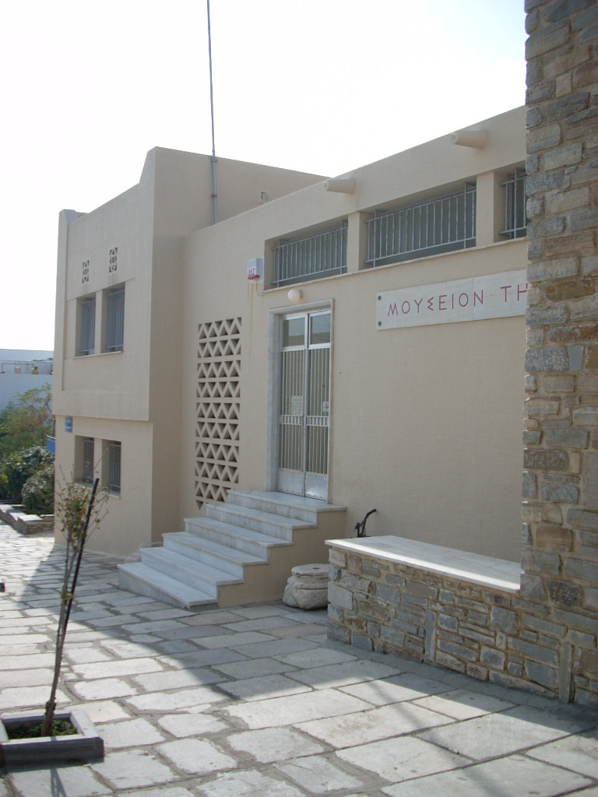 Fig.1. The Tinos archaeological museum, entrance.

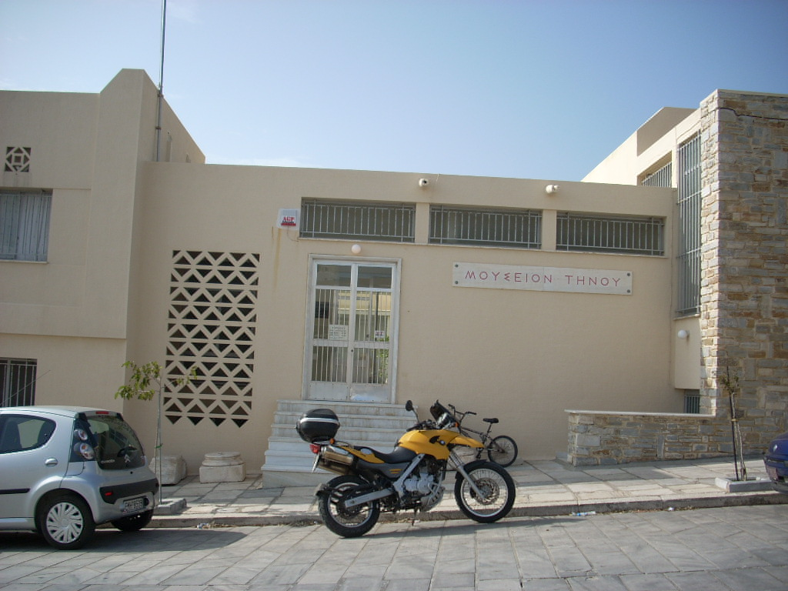
Fig. 2. The Tinos archaeological museum, entrance.

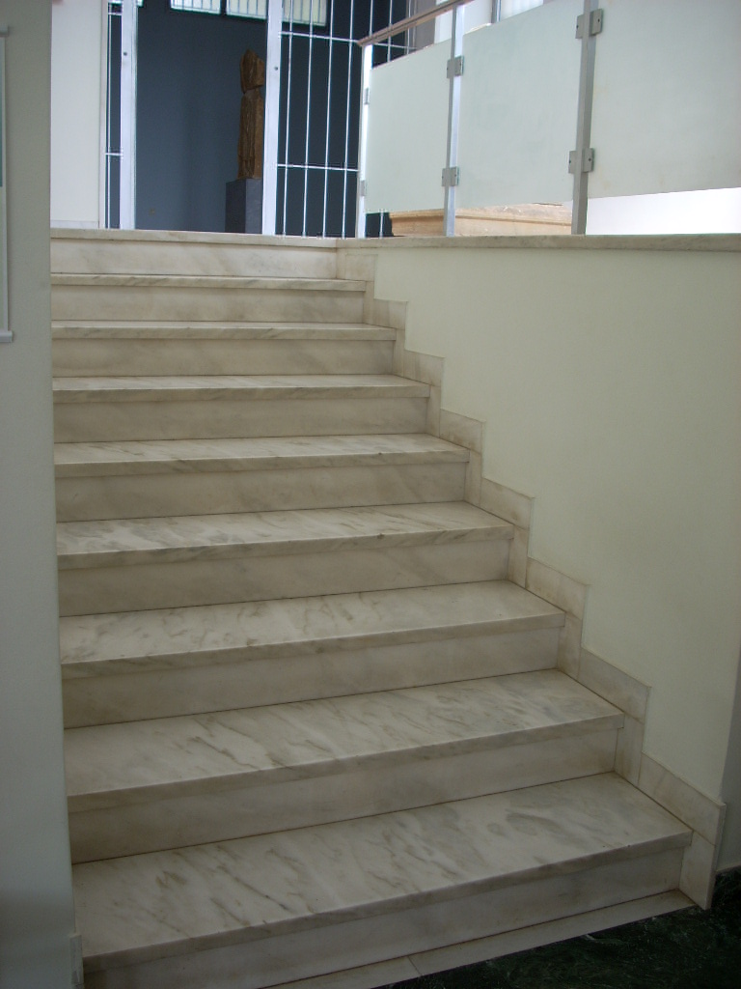 Fig.3. Inside the museum stairs.

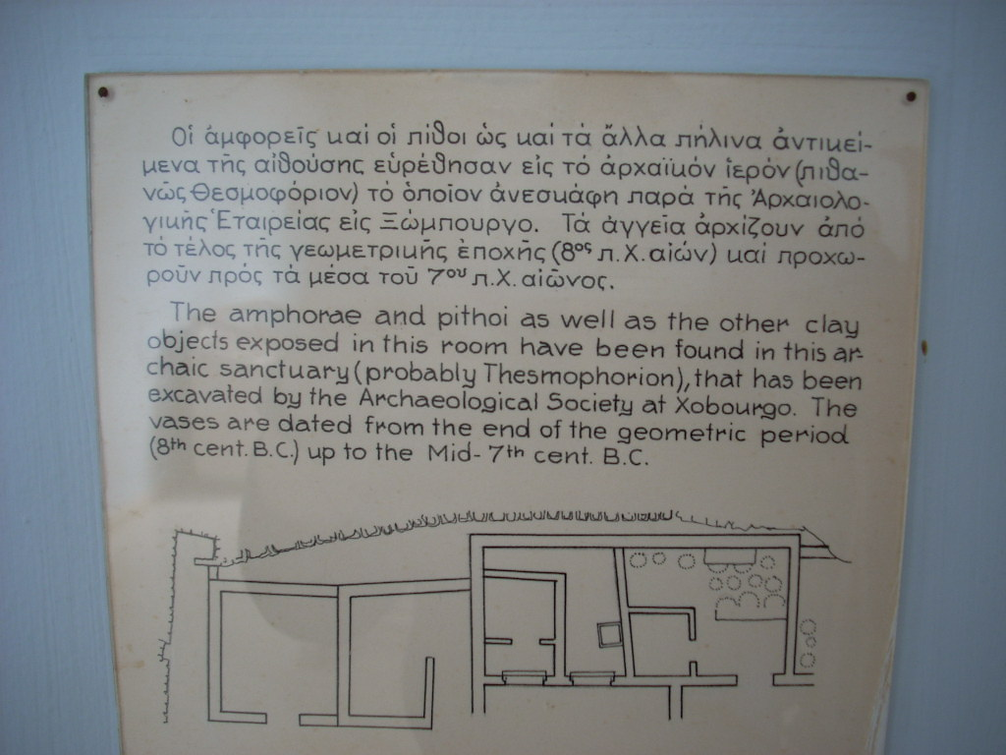

Fig. 4. An explanatory label, since 1960’s.

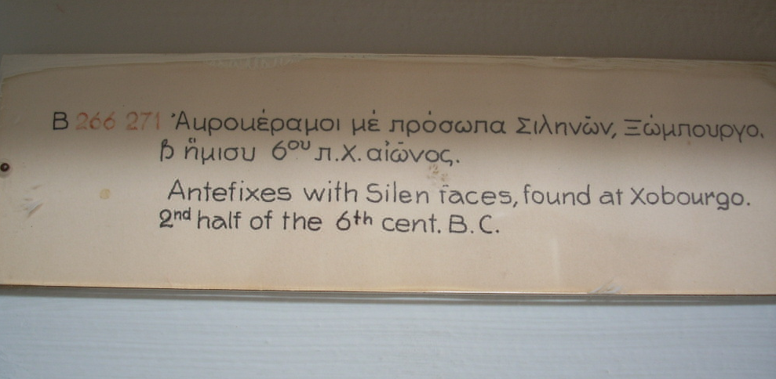
Fig. 5. Objects’ label.

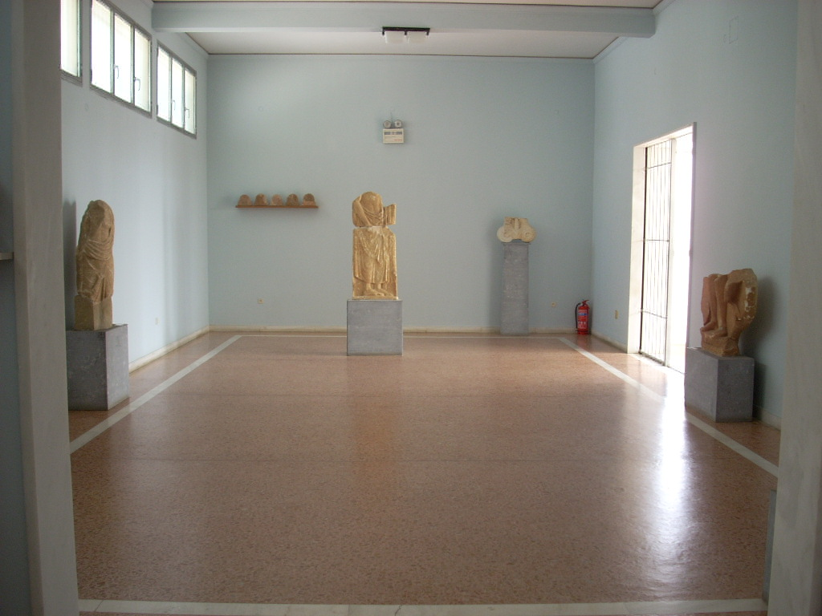
Fig. 6. Inside the museum, an exhibition’s room.

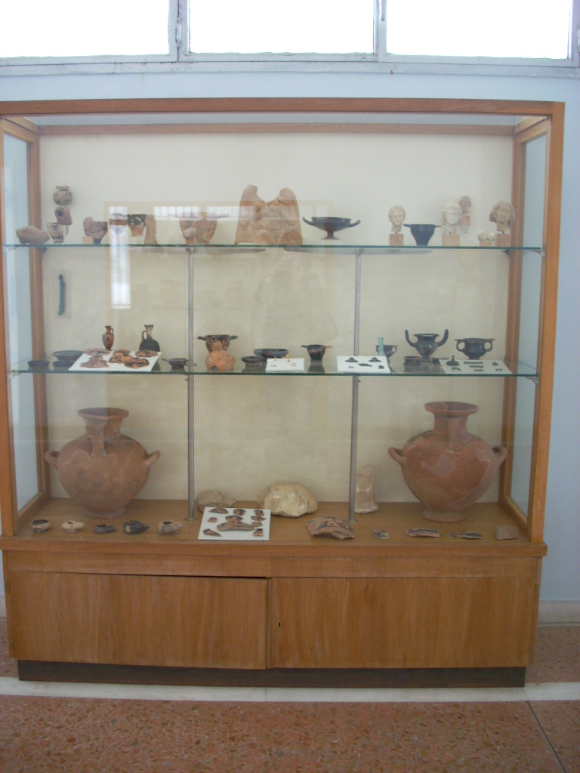 Fig. 7. A case.

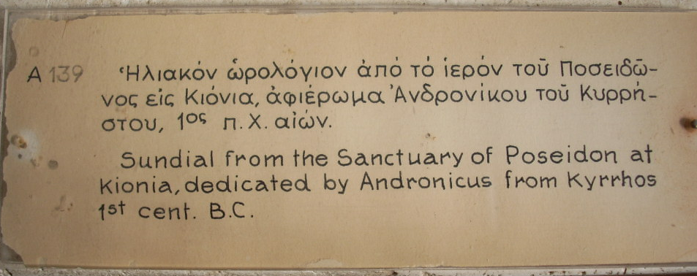
Fig. 8. An explanatory label.

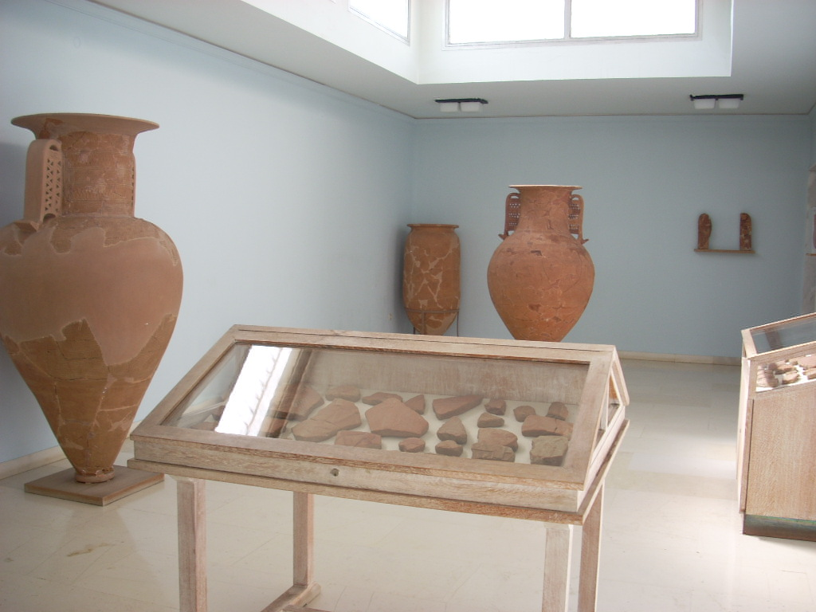
Fig. 9. An exhibition’s room.

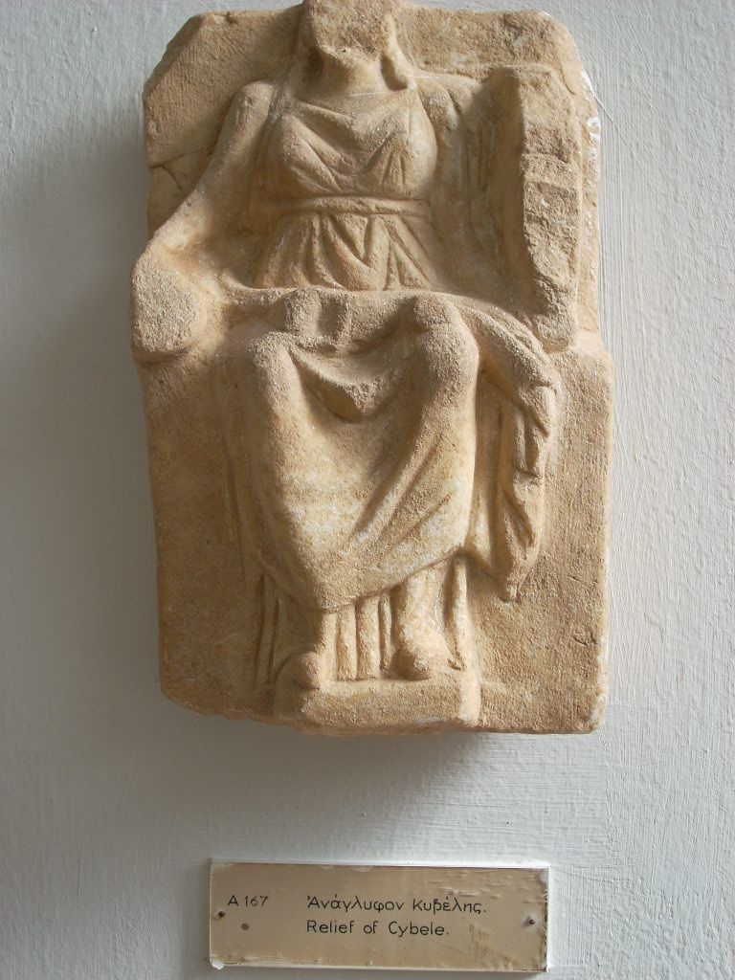 Fig. 10. An object with its label.

Bibliography

(The bibliography is missing for logical reasons.)

Hooper-Greenhill, E., 2006. Reussner, Eva M, 2007.
Hooper-Greenhill, E., 1994.
Pennington, A., 2002.
Ambrose, T., 1993.
Hooper-Greenhill, E., 1994.
Ambrose, T. and Paine, C., 2006.
Ambrose, T. and Paine, C., 2006.
Ambrose, T., 1993.
Ambrose, P. and Paine, C., 2006.
Dodd, J. and Sandell, R., 1998.
Ambrose, T 1993.
Pennington, A., 2002.
Armstrong, G. and Kotler, P., 2003.
Ambrose, P. and Paine, C., 2006.
Ibid. Hood, M. G., 1995.
Pennington, A., 2002.
Ambrose, P. and Paine, C., 2006.
Pennington, A., 2002.
Ibid.
Cameron, Duncan F., 1982.
Cameron, Duncan F., 1982.
Ibid.
Ibid.
Ibid.
Ibid.
Hood, Marilyn G., 1983.
Hood, Marilyn G., 1983.
Ibid.
Ibid.
Ibid.
Ibid.
Prince, David R., 1990.
Prince, David R., 1990.
Ibid.
Ibid.
Ibid.
Ibid.
Trevelyan Vanessa, 1991.
Trevelyan Vanessa, 1991.
Trevelyan Vanessa, 1991. Trevelyan Vanessa, 1991.
Trevelyan Vanessa, 1991.
Nottingham City Museums and Art Gallery, 1993.
Ibid.
Ibid.
Ibid.
Ibid.
Nottingham City Museums and Art Gallery, 1993.
Ibid.
Ibid.
Ibid.
Ibid.
Ibid.
Ibid.
Nottingham City Museums and Art Gallery, 1993.
Dodd, J. and Sandell, R., 1998.
Ibid.
Dodd, J. and Sandell, R., 1998.
Ibid.
Ibid.
Dodd, J. and Sandell, R., 1998.
Ibid.
Ibid.
Ibid.
Ibid.
Ibid.
Ibid.
Ibid.
Ibid.
Ibid.
As found through my personal research, for this study, in Greek ICOM and after discussion with Ms. Teti Chatzinikolaou (Dirctor of ICOM, Greece), in May, 2007.
University of Southampton, Archaeology, School of Humanities, ‘The Quseir al-Qadim Project - an introduction’.
Pennington, A., 2002.
Ibid.
Ibid. Department of Museum Studies, University of Leicester, 2006/2007.
Pennington, A., 2002.
Department of Museum Studies, University of Leicester, 2006/2007.
Pennington, A., 2002.
Ibid.
McLean, Fiona, 1997.
Holloway, Immy, 1997.
Denscombre, Martyn, 1998.
Holloway, Immy, 1997.
Marshall, E. and Rossman, Gretchen B., 1995.
Ibid. Maxwell, Joseph A., 2005.
Marshall, E. and Rossman, Gretchen B., 1995.
Ibid.
Marshall, E. and Rossman, Gretchen B., 1995.
Marshall, E. and Rossman, Gretchen B., 1995.
Ibid.
Denscombre, Martyn, 2003.
Denscombre, Martyn, 1998.
Kolb, Bonita M., 2000.
Ibid.
Kolb, Bonita M., 2000.
SMQ (Société des musées québécois), 2001.
Conybeare, Clare, 1991.
Denscombre, Martyn 1998.
Ibid.
Conybeare, Clare, 1991.
Denscombre, Martyn, 1998.
Kolb, Bonita M., 2000. McLean, Fiona, 1997.
Denscombre, Martyn, 1998.
Holloway, Immy, 1997.
Department of Museum Studies, University of Leicester, 2006/2007.
Maxwell, Joseph A., 2005.
Pennington, A., 2002.
Denscombre, Martyn, 1998.
Yin, Robert K., 1994.
Holloway, Immy, 1997.
Denscombre, Martyn, 1998.
Ibid.
Yin, Robert K., 1994.
Denscombre, Martyn, 1998.
Ibid.
Denscombre, Martyn, 1998.
Ambrose, T., 1993. Black, Graham, 2006. Hooper-Greenhill, 2001. Ingenthron, Mary Kay, 2001. Kotler, Neil and Kotler, Philip, 1998. Majewski, Janice, 1993.
Trevelyan Vanessa, 1991. Nottingham City Museums and Art Gallery, 1993.
Trevelyan Vanessa, 1991. McLean, Fiona, 1997. Niehoff, Arthur, 1968. Rand, Judy 2001. RE:SOURCE, 2001. Roper, Patrick, 1996. Runyard, Sue and French, Ylva, 1999.
Dickman, Sharron, 1995.
Hood, Marilyn G., 1983. Trevelyan Vanessa, 1991. Nottingham City Museums and Art Gallery, 1993.
Trevelyan Vanessa, 1991.
Nottingham City Museums and Art Gallery, 1993.
Ambrose, T., 1993. Black, Graham, 2006. Dickman, Sharron, 1995. Huang, Kuang-Nan, 1997.
Screven, C. G., 1995.
Hooper-Greenhill, Eilean, 1994.
Hirschi, Kent D. and Screven, Chandler, 1996. Hein, George E., 1998. Hooper-Greenhill, Eilean, 1994. Ekarv, Margareta, 1994.
Trevelyan Vanessa, 1991.
Trevelyan Vanessa, 1991. Nottingham City Museums and Art Gallery, 1993.
Cameron, Duncan F., 1982.
Trevelyan Vanessa, 1991.
Nottingham City Museums and Art Gallery, 1993.
French, Ylva, 1991. Getty Centre for Education in the Arts, 1991. Kotler, Neil and Kotler, Philip, 1998. Rand, Judy, 2001. Research Centre for Museums and Galleries, 2002.
Nottingham City Museums and Art Gallery, 1993.
Wright, Philip, 1989. Ingenthron, Mary Kay, 2001. Research Centre for Museums and Galleries, 2002.
Trevelyan Vanessa, 1991.
Ambrose, T., 1993. McLean, Fiona, 1997.
Migliorino, Pino, 1995.
Ingenthron, Mary Kay, 2001. Kotler, Neil and Kotler, Philip, 1998. Migliorino, Pino, 1995. Rand, Judy 2001.
Ambrose, T., 1993. Groff, Gerda with Gardner, Laura, 1990. Majewski, Janice, 1993. Morris, Gerri, 1991.
Getty Centre for Education in the Arts, 1991.
Adams, Donald, 1983. Dickman, Sharron, 1995. Morris, Gerri, 1991. French, Ylva, 1991. Perin, Constance, 1992.
Black, Graham, 2006. Hood, M. G., 1995. Huang, Kuang-Nan, 1997.
Dodd, J. and Sandell, R., 1998. Hood, Marilyn G., 1983. Trevelyan Vanessa, 1991. Nottingham City Museums and Art Gallery, 1993.
Dickman, Sharron, 1995.
Trevelyan Vanessa, 1991.
Ambrose, T., 1993. Adams, Donald, 1983.
Hood, Marilyn G, 1983. Dickman, Sharron, 1995. Migliorino, Pino, 1995. Trevelyan Vanessa, 1991.
Faber, Michael, 1992. Ambrose, T., 1993. McLean, Fiona, 1997. Huang, Kuang-Nan, 1997. Museums & Galleries Commission, 1994.
Nottingham City Museums and Art Gallery, 1993.
Dickman, Sharron, 1995.
Trevelyan Vanessa, 1991.
Prince, David R., 1990.
Black, Graham, 2006. Majewski, Janice, 1993. McLean, Fiona, 1997. Niehoff, Arthur, 1968. Rand, Judy, 2001. RE:SOURCE, 2001. Roper, Patrick, 1996. Runyard, Sue and French, Ylva, 1999. Salmen, John, 2001. Trevelyan Vanessa, 1991.
Faber, Michael, 1992. Groff, Gerda with Gardner, Laura, 1990.
Research Centre for Museums and Galleries, 2002.
Ambrose, T., 1993. Black, Graham, 2006. Hooper-Greenhill, 2001. Ingenthron, Mary Kay, 2001. Kotler, Neil and Kotler, Philip, 1998. Majewski, Janice, 1993. Rand, Judy, 2001.
Black, Graham, 2006. Hooper-Greenhill, 2001. Huang, Kuang-Nan, 1997.
Ambrose, T., 1993. Black, Graham, 2006. Dickman, Sharron, 1995. Huang, Kuang-Nan, 1997. Niehoff, Arthur, 1968.
Adams, Donald, 1983. Black, Graham, 2006. Morris, Gerri, 1991. Niehoff, Arthur, 1968. Rand, Judy, 2001.
Black, Graham, 2006. Ingenthron, Mary Kay, 2001.
Edson, Garry and David, Dean, 2001. Trevelyan Vanessa, 1991.
Adams, Donald, 1983. Bitgood, Stephen C, 1987. Ambrose, T., 1993. Black, Graham, 2006. Getty Centre for Education in the Arts, 1991. Rand, Judy, 2001.
Sorsby, B. and Horne, S., 1980.
Jacobi, Daniel and Poli, Marie Sylvie, 1995. Majewski, Janice, 1993. Niehoff, Arthur, 1968. Runyard, Sue and French, Ylva, 1999.
Serrell, Beverly, 1996. Kentley, E. and Negus, D., 1989. Blais, Andree, 1995. Serrell, Beverly, 1983. Durbin, Gail, 1996.
Research Centre for Museums and Galleries, 2002.
French, Ylva, 1991. Getty Centre for Education in the Arts, 1991. Kotler, Neil and Kotler, Philip, 1998. Rand, Judy, 2001. Research Centre for Museums and Galleries, 2002. Runyard, Sue and French, Ylva, 1999. Trevelyan Vanessa, 1991.
Cameron, Duncan F., 1982.
Sandell, Richard, ‘Social Inclusion, the museum and the dynamics of sectoral change’.
Dickman, Sharron, 1995. Majewski, Janice, 1993. Niehoff, Arthur, 1968.
Ambrose, T., 1993. Morris, Gerri, 1991. Runyard, Sue and French, Ylva, 1999.
Ambrose, T., 1993.
Ambrose, T., 1993. Groff, Gerda with Gardner, Laura, 1990. Majewski, Janice, 1993. Morris, Gerri, 1991.
Wright, Philip, 1989.
Ingenthron, Mary Kay, 2001. Research Centre for Museums and Galleries, 2002. Roper, Patrick, 1996.
Ambrose, T., 1993. Roper, Patrick, 1996.
Ambrose, T., 1993. McLean, Fiona, 1997.
Ingenthron, Mary Kay, 2001. Kotler, Neil and Kotler, Philip, 1998. Rand, Judy, 2001.
Sandell, Richard, ‘Social Inclusion, the museum and the dynamics of sectoral change’.
Ambrose, T., 1993. Adams, Donald, 1983. Morris, Gerri, 1991. French, Ylva, 1991. Perin, Constance, 1992.
Getty Centre for Education in the Arts, 1991. Huang, Kuang-Nan, 1997.
Kotler, Neil and Kotler, Philip, 1998.
Black, Graham, 2006. Huang, Kuang-Nan, 1997.
Hood, M. G., 1995.
Adams, Donald, 1983.
Ambrose, T., 1993. Adams, Donald, 1983.
Ambrose, T., 1993. Research Centre for Museums and Galleries, 2002. RE:SOURCE, 2001. Special Committee of the American Association of Museums, 1972.
Faber, Michael, 1992.
Ambrose, T., 1993. French, Ylva, 1991. Kotler, Neil and Kotler, Philip, 1998. Salmen, John, 2001. Veal, F. R., 1983.
Ambrose, T., 1993. McLean, Fiona, 1997. Huang, Kuang-Nan, 1997. Museums & Galleries Commission, 1994. Roper, Patrick, 1996.
McLean, Fiona, 1997.
Runyard, Sue and French, Ylva, 1999. Museums & Galleries Commission, 1994.
Ambrose, T., 1993.
Ibid. French, Ylva, 1991. McLean, Fiona, 1997.
French, Ylva, 1991.
Reussner, Eva M., 2007.
Kotler, Philip, 2003.
McLean, Fiona, 1997.
Ambrose, T., 1993.

